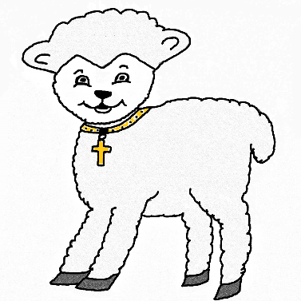
Little Lamb Preschool
St Paul Lutheran Church
Registration 2024-2025

Child’s Name:________________________________________
Parent’s Name:_______________________________________
Address: ____________________________________________
Phone #:_____________________________________________
Child’s Birthday ___/___/___
(Must be age 3 by Sept 15 and must be potty trained)

Little Lamb Preschool admits students of any race, color, and national ethnic origin to all the rights, privileges, programs, and activities generally accorded or made available to students at the school. It does not discriminate based on race, color, national and ethnic origin in administration of policies, scholarships, and other school- administered programs.

Please send or drop off this form and $50 registration fee (no refunds) Payment by Checks Only
to:
Little Lamb Preschool
C/O St. Paul Lutheran Church
1844 Highland Dr
Carroll, IA 51401
(Make checks payable to Little Lamb Preschool)

______ I would like to enroll my 3-year-old.
______ I would like to enroll my 4-year-old.
Class will be Monday through Thursday.
Tuition is $100/month.

Morning Session 8:00 - 11:00
If you have any questions, please feel free to contact
Durene Eisenbacher at 712-292-9751 or LittleLamb@stpaul-ia.com

